GoDesign Technologies LLP

Definition
# Source: ScreenShots Source: Provided by: [Persons Table -> ID Column: 1, Name_En Column: Motasem Essam] -> Tool: [Lightshot Program] -> From [Site: https://godesign.pk/] on [2/12/2026]
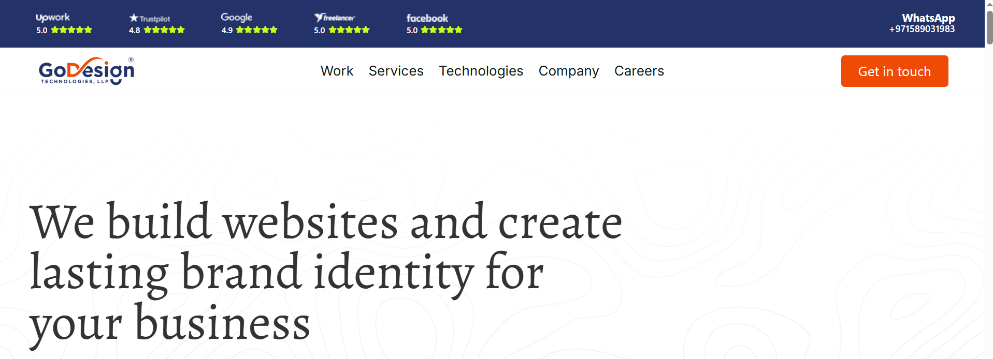
# Source: AI Source: Provided by: [Data Path: Persons Table -> ID Column: 1, Name_En Column: Motasem Essam] -> From: [ChatGPT] on [2/12/2026]
GoDesign Technologies LLP is a digital and creative agency / IT services company that provides web design, branding, and technology solutions to businesses globally. (About.me)

📌 Overview
# Source: AI Source: Provided by: [Data Path: Persons Table -> ID Column: 1, Name_En Column: Motasem Essam] -> From: [ChatGPT] on [2/12/2026]
- It’s commonly known as GoDesign Technologies LLP and operates as a digital agency specializing in web and brand services. (About.me)
- The company appears to be active in Pakistan, particularly in Islamabad, and works with clients worldwide. (Clutch)
- Some listings also show a New York City address, but the core operations are predominantly online and Pakistan-based. (StartUs)

💼 What the Company Does
# Source: AI Source: Provided by: [Data Path: Persons Table -> ID Column: 1, Name_En Column: Motasem Essam] -> From: [ChatGPT] on [2/12/2026]
GoDesign Technologies LLP offers a range of services including:
- Website design & development (especially WordPress, Shopify, and modern web frameworks like React) (GoDesign Technologies LLP)
- Brand identity & graphic design, including logo and stationery design (GoDesign Technologies LLP)
- Digital marketing and SEO services for online presence and growth (GoDesign Technologies LLP)
- Custom web solutions and other technology services for businesses and startups (Clutch)

🧠 Business Context
# Source: AI Source: Provided by: [Data Path: Persons Table -> ID Column: 1, Name_En Column: Motasem Essam] -> From: [ChatGPT] on [2/12/2026]
- The company was established around 2019 and serves small to medium-sized companies globally, helping them build online presence and digital products. (Clutch)
- It offers services on an hourly or project basis, with a typical rate range and team of designers and developers. (Clutch)

summary
# Source: AI Source: Provided by: [Data Path: Persons Table -> ID Column: 1, Name_En Column: Motasem Essam] -> From: [ChatGPT] on [2/12/2026]
In summary, GoDesign Technologies LLP is best described as a full-service digital agency and technology partner that helps businesses create websites, develop brands, and grow online. (About.me)

